ITA0608 - Machine Learning

Confusion Matrix Aim
To implement a Decision Tree Classifier using Python and evaluate its performance by generating a
Confusion Matrix.

Algorithm

- Import the required libraries.
- Load the dataset from the trainingdata.csv file.
- Separate the features (X) and target (y).
- Convert categorical data into numerical values if necessary.
- Split the dataset into training and testing sets.
- Train the Decision Tree classifier using the training data.
- Predict the class labels for the test data.
- Generate the Confusion Matrix.
- Display the Confusion Matrix and classification accuracy.

Program

import pandas as pd

from sklearn.tree import DecisionTreeClassifier

from sklearn.model_selection import train_test_split from sklearn.metrics import ConfusionMatrixDisplay import matplotlib.pyplot as plt
data = pd.read_excel("student_data.xlsx")

X = data[['Hours_Studied', 'Attendance']] y = data['Pass']

X_train, X_test, y_train, y_test = train_test_split( X, y, test_size=0.3, random_state=42
)

model = DecisionTreeClassifier() model.fit(X_train, y_train) y_pred = model.predict(X_test)
ConfusionMatrixDisplay.from_predictions(y_test, y_pred) plt.show()

Output
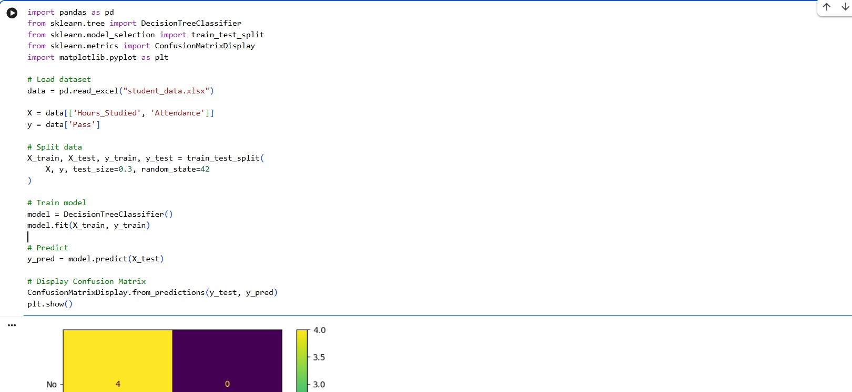

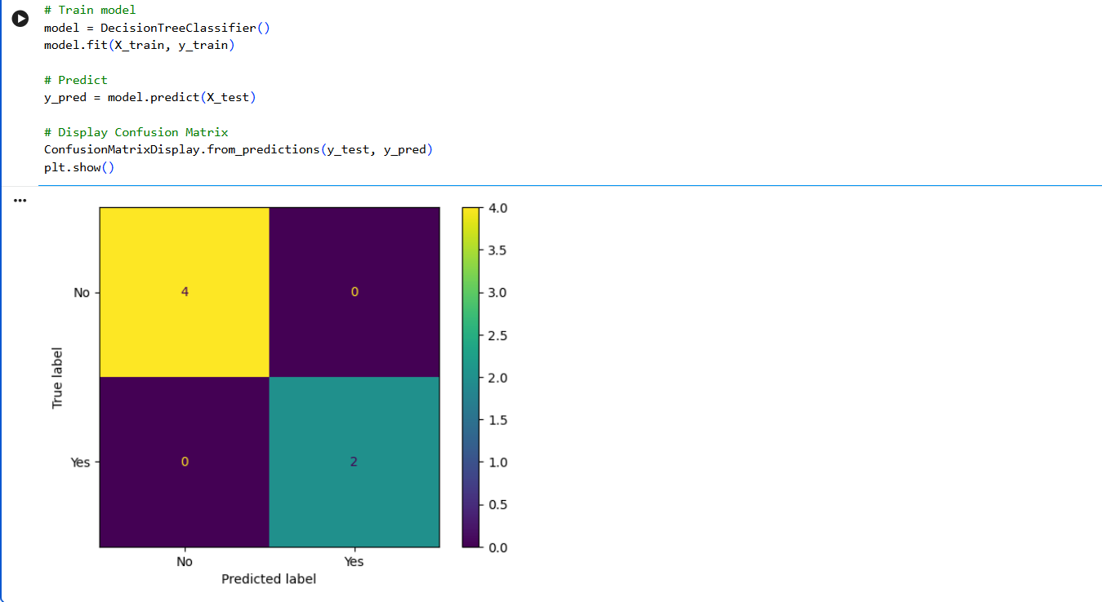

Result

The Decision Tree Classifier was successfully implemented using Python. The model was evaluated using a Confusion Matrix, and the classification accuracy was found to be 100% (1.0) for the given dataset.

